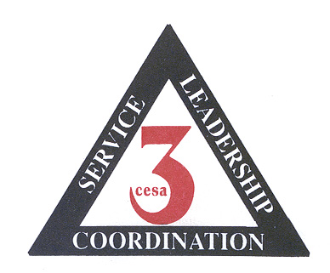

Course Description:

Overall mini grant funding has been cut this year. This means this process will be extremely competitive. Bring your student grant writing team to this special event where you will have time to network and share your ideas regarding your student mini grants. You will learn the ins and outs on how to write mini grants and have some fun. In the afternoon there will be time to write your grant with your student team and get technical assistance from Deb Goold.

To get a head start on your mini grant application, go to

http://dpi.wi.gov/sspw/miniprog.html

Wisconsin Teacher Standards

4. Teachers know how to teach.

6. Teachers communicate well.

10 Teachers are connected with other teachers and the community.

CESA #3 AODA Network presents
Grant Writing Workshop
For AODA Mini Grants

Date & Time | Facilitator | Level | Location
September 19, 2011  9:00 am – 1:30 pm  Registration 8:30 – 9:00 | Deb Goold | Any grade level, student teams with 1 adult leader | CESA #3  Room C/D

Yes, it is time to take your students needs for prevention along with their innovative ideas and work on a grant proposal for next school year. If you have never heard of AODA Student Mini Grants they are for funding wellness & prevention projects targeting AODA or other youth risk behaviors (tobacco, bullying, HIV, suicide) developed by students for students.
Who can apply? Any group of students in grades K-12 can fill out the application to describe a prevention or wellness project they are interested in.
What can we get? Each funded project may be awarded up to $1,000.
When are they available? Applications are mailed to your district in August and available on the DPI website. They are due at CESA #3 by October 1st. The project needs to be completed and final claim submitted by May 30, 2011.
What are some good ideas for projects? Good ideas for projects include peer helper or educator programs, wellness fairs, prevention skits, awareness campaigns for parents and community members.
What are ATS Projects? The development of youth projects targeting Alcohol Traffic Safety (ATS), such as SADD chapters, Just-Say-No clubs, or any other creative group activity are appropriate use of the funds.

Space is limited to 10 teams of 4-6 student members and 1 adult
Register early to assure your space
This workshop is free – BRING YOUR OWN LUNCH!

To Register –
NOTICE:

You will need to access the CESA #3 webpage at www.cesa3.k12.wi.us and locate the Student Mini Grant on September 19 under Calendar of Events on the left side of the page. This will allow you to register an advisor for this event. Then we are asking that you place the number of students attending in the notes box.

Contact Sue McLimans, smclimans@cesa3.k12.wi.us or 608-822-3276 ext 254 if you have questions.

